Kevin Serina

BCS360 Final Project

Professor Lees

Company: Netflix

**Overview of the Company**

* Netflix, Inc. is an American media-services provider and production company headquartered in Los Gatos, California, founded in 1997 by Reed Hastings and Marc Randolph in Scotts Valley, California.
* The company’s primary business is its subscription-based streaming service which offers online streaming of a library of films and television programs, including those produced in-house.
* `As of April 2019, Netflix had over 148 million paid subscriptions worldwide, including 60 million in the United States, and over 154 million subscriptions total including free trials.

**Requirements Identified**

A **CUSTOMER** makes 1 **PAYMENT** per month

A **CUSTOMER** has 1 **SUBSCRIPTION**

A **PAYMENT** contains a **PAYMENT HISTORY**

A **SUBSCRIPTION** contains many **MOVIES**

A **SUBSCRIPTION** contains many **TVSHOWS**

A **GENRE** belongs to many **MOVIES**

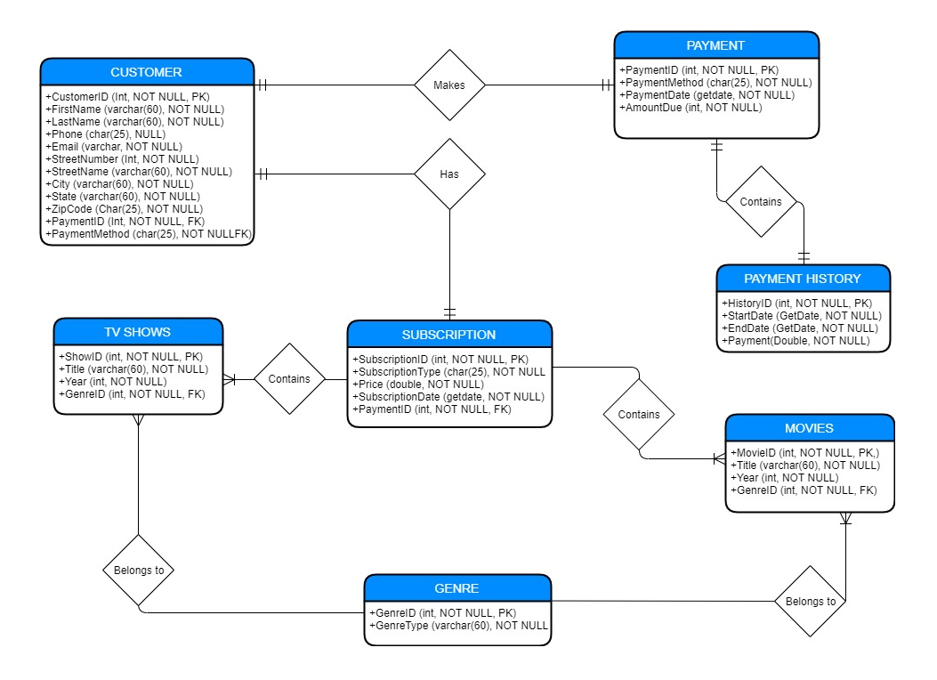A **GENRE** belongs to many **TVSHOWS**

**Netflix ER Model**

**Database Schema Design**

CUSTOMER

|  |  |  |  |
| --- | --- | --- | --- |
| CustomerID | Int | NOT NULL | PK |
| FirstName | Varchar(60) | NOT NULL |  |
| LastName | Varchar(60) | NOT NULL |  |
| Phone | Char(25) | NULL |  |
| Email | Varchar(60) | NOT NULL |  |
| StreetNumber | Int | NOT NULL |  |
| StreetName | Varchar(60) | NOT NULL |  |
| City | Varchar(60) | NOT NULL |  |
| CustState | Varchar(60) | NOT NULL |  |
| ZipCode | Char(25) | NOT NULL |  |
| PaymentID | Int | NOT NULL | FK |

SUBSCRIPTION

|  |  |  |  |
| --- | --- | --- | --- |
| SubscriptionID | Int | NOT NULL | PK |
| SubscriptionType | Char(25) | NOT NULL |  |
| Price | Double | NOT NULL |  |
| SubcriptionDate | GetDate | NOT NULL |  |
| PaymentID | Int | NOT NULL | FK |

PAYMENT

|  |  |  |  |
| --- | --- | --- | --- |
| PaymentID | Int | NOT NULL | PK |
| CardNumber | Char(25) | NOT NULL |  |
| PaymentDate | GetDate | NOT NULL |  |
| AmountDue | Money | NOT NULL |  |

MOVIES

|  |  |  |  |
| --- | --- | --- | --- |
| MovieID | Int | NOT NULL | PK |
| Title | VarChar(60) | NOT NULL |  |
| Year | Int | NOT NULL |  |
| GenreType | Varchar(60) | NOT NULL | FK |

TV SHOWS

|  |  |  |  |
| --- | --- | --- | --- |
| ShowID | Int | NOT NULL | PK |
| Title | VarChar(60) | NOT NULL |  |
| Year | Int | NOT NULL |  |
| GenreType | Varchar(60) | NOT NULL | FK |

PAYMENT HISTORY

|  |  |  |  |
| --- | --- | --- | --- |
| HistoryID | Int | NOT NULL | PK |
| StartDate | GetDate | NOT NULL |  |
| EndDate | GetDate | NOT NULL |  |
| Payment | Double | NOT NULL |  |
| CustomerID | Int | NOT NULL | FK |

GENRES

|  |  |  |  |
| --- | --- | --- | --- |
| GenreID | Int | NOT NULL | PK |
| GenreType | VarChar(60) | NOT NULL | PK |

**Stored Procedures**

USE [serik]

GO

/****** Object: StoredProcedure [dbo].[spAddNewCustomer] Script Date: 12/8/2019 2:36:29 AM ******/

SET ANSI_NULLS ON

GO

SET QUOTED_IDENTIFIER ON

GO

/* This stored procedure is created for whenever a new customer makes a subscription, the customer details are added into the customer table */

CREATE PROC [dbo].[spAddNewCustomer]

@FirstName varchar(60),

@LastName varchar(60),

@Email varchar(60),

@StreetNumber int,

@StreetName varchar(60),

@City varchar(60),

@CustState varchar(60),

@ZipCode char(25),

@PaymentID int

AS

BEGIN

INSERT INTO CUSTOMER (FirstName, LastName, Email, StreetNumber, StreetName, City, CustState, ZipCode, PaymentID)

VALUES (@FirstName, @LastName, @Email, @StreetNumber, @StreetName, @City, @CustState, @ZipCode, @PaymentID)

END

GO

USE [serik]

GO

/****** Object: StoredProcedure [dbo].[spCustomerSubscription] Script Date: 12/8/2019 2:40:14 AM ******/

SET ANSI_NULLS ON

GO

SET QUOTED_IDENTIFIER ON

GO

CREATE PROC [dbo].[spCustomerSubscription]

@CustID int

AS

SELECT CustomerID, FirstName, LastName, SubscriptionID, SubscriptionType, Price

FROM CUSTOMER c

INNER JOIN SUBSCRIPTION s

ON c.CustomerID = s.SubscriptionID

WHERE c.CustomerID = @CustID;

GO

USE [serik]

GO

SET ANSI_NULLS ON

GO

SET QUOTED_IDENTIFIER ON

GO

/* This stored procedure is created to see when the due date of a customers payment subscription is and how much they owe. */

CREATE PROC spDueDate

@CustomerID int

AS

SELECT c.CustomerID,

c.FirstName,

c.LastName,

ph.StartDate,

DATEADD(d, 30, StartDate) AS DueDate

FROM CUSTOMER c

INNER JOIN PAYMENTHISTORY ph

ON c.CustomerID = ph.CustomerID

WHERE @CustomerID = c.CustomerID

GO

**Solution Design**

